Please leave these first three lines blank for the Editors
Please leave these first three lines blank for the Editors
Please leave these first three lines blank for the Editors
EXTRACTION OF ANTIOXIDANT PHENOLIC COMPOUNDS BY AUTOHYDROLYSIS OF SPENT COFFEE GROUNDS
Please leave this line blank
L---- F B------^{1(*)}, E---- M S M—¹, M--- J R----- ², C--- O---⁵, S--- M--- ¹ and J--- A T----
¹ Centre of -------, University of ----, City, Country
² Department of ---, University of ---, City, Country
^{(*)}Email: l-----@-----
Please leave these two lines blank
Please leave these two lines blank
ABSTRACT
The extraction of antioxidant phenolic compounds from spent coffee grounds (SCG) was carried out by the autohydrolysis technique, evaluating the effect of the process variables such as temperature, water/SCG ratio and time on the amount of phenolic compounds and antioxidant activity of the extracts, according to a 23 central composite design. The statistical model revealed that the optimum condition to produce extracts with high phenolic compound content (35.07 mg GAE/g SCG) and antioxidant activity (FRAP=0.25 mmol Fe(II)/g SCG, DPPH= 121.7 µmol TE/g SCG, ABTS=130.0 µmol TE/g SCG, TAA= 64.17 mg α-TOC/g SCG) was achieved when maximizing process variable (Temperature =200°C, ratio = 15 ml/g and time=50 min).
Please leave these two lines blank
Please leave these two lines blank
INTRODUCTION
Previous researches have shown that the potential of phenolic compounds is related to their antioxidant activity, protecting against chronic-degenerative diseases as cancer, diabetes, and also presenting anti-inflammatory, antiallergenic and antimicrobial effect [1, 2].
Recently, SCG have been studied as a natural source of phenolic compounds by conventional solid-liquid method, using organic solvents such as ethanol and methanol [3, 4]. The aim of the present study is to extract antioxidant phenolic compounds from SCG using an eco-friendly technique, namely autohydrolysis. Additionally, the conditions able to produce a phenolic rich extract with high antioxidant activity were optimized.
Please leave these two lines blank
Please leave these two lines blank

MATERIALS AND METHODS
Extractions were performed by authohydrolysis, under different temperature (160 to 200°C), liquid/solid ratio (5 to 15 ml water/ g SCG) and extraction time (10 to 50 min), which were combined according to a 23 central composite design. Total phenolic compounds was determined by the Folin-Ciocalteu method and the antioxidant potential of the extracts was quantified by FRAP, DPPH, ABTS and total antioxidant activity (TAA). Statistical analysis of the results was performed to identify the influence of each variable on the responses, and the conditions able to maximize the extraction of antioxidant phenolic compounds were established.
Please leave these two lines blank
Please leave these two lines blank

RESULTS
The statistical analysis revealed a significant effect of the three variables on the total phenolic compounds extraction from the spent coffee grounds (SCG), being the ratio the most significant variable on the process, as shown in Figure 1. As a result, similar trends on the antioxidant responses were also found.
All the responses were fitted to second-order polynomial equations, where the terms with non-statistical significance (p<0.05) were disregarded in order to improve the fitting and prediction of the model.
A graphical optimization was carried out in order to determine the proper extraction condition to obtain high content of total phenolic compounds, as well as high antioxidant activity of the extracts. The optimization process was conducted by overlapping the responses curves obtained in the model, based on the mathematical description of each variable and imposing the following criteria: TP > 35, FRAP > 0.23, TAA > 60, ABTS > 110, and DPPH > 100. Figure 2 shows the result of the described methodology where the ratio and the time variable are presented in the range studied while the temperature was limited to 200 °C. The graph reveals an area in which these criteria are satisfied (yellow area), in which the optimized extraction is obtained when the processes variable are maximized (Temperature = 200°C, ratio = 15 ml/g and time = 50 min).

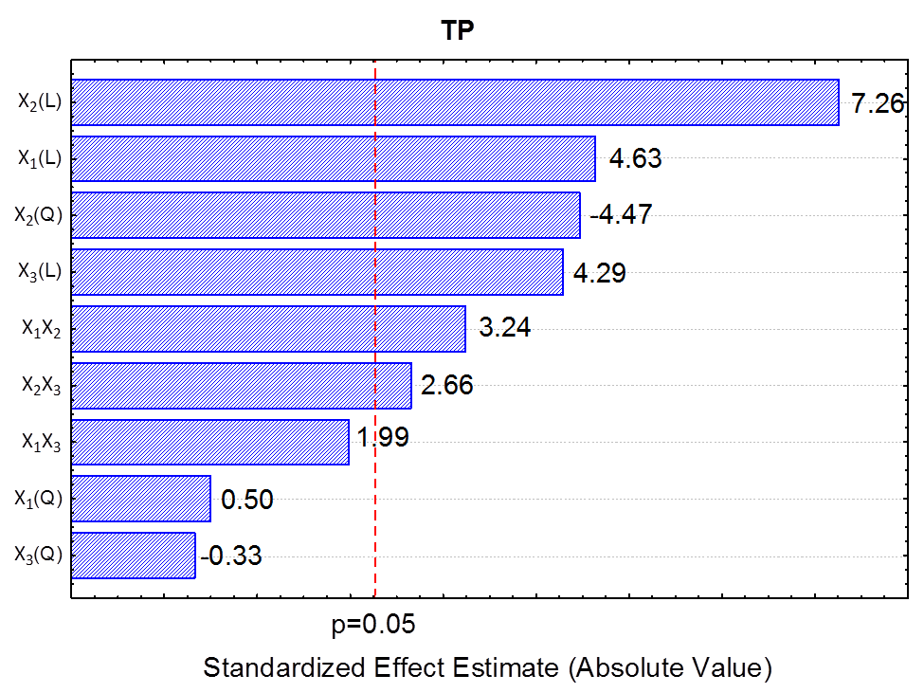 | 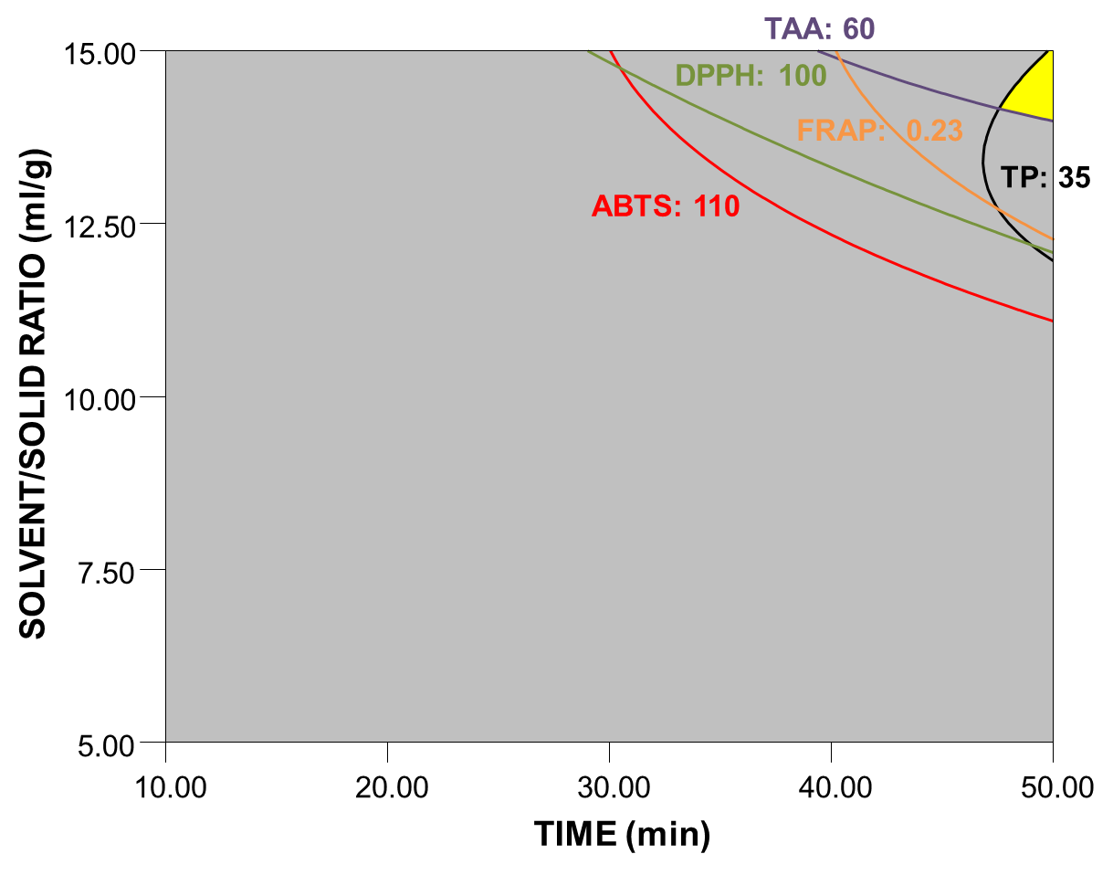
Figure 1. Pareto chart for the effects of temperature (X₁), ratio (X₂) and extraction time (X₃), during the autohydrolisys of spent coffee grounds, on the total phenolic compounds. |  | Figure 2. Optimum region by overlaying the curves of the responses total phenolic compounds (TP), FRAP, DPPH, ABTS and antioxidant activity (TAA) as a function of time and ratio used for spent coffee ground extraction.

Please leave these two lines blank
Please leave these two lines blank
CONCLUSIONS
Spent coffee grounds are a raw material of great interest for use on biotechnological processes due to their low cost and availability, and mainly due to their antioxidant capacity and presence of phenolic compounds. The eco-friendly extraction method used in the present study revealed the great potential of this residue for industrialization. The optimal condition predicted an extract with 35.07 mg GAE/g SCG of total phenolic compounds and antioxidant activity of FRAP = 0.25 mmol Fe(II)/g SCG, DPPH = 121.75 µmol TE/g SCG, ABTS= 130.01 µmol TE/g SCG and TAA= 64.17 mg α-TOC/g SCG. These predicted values are in agreement with the values obtained experimentally, which can be seen in table 1 for the conditions (+1, +1, +1). The optimal point was later reproduced to validate the results, obtaining values within 5 % of relative standard deviation, which demonstrate a good degree of prediction.The present study also revealed higher phenolic compound extraction when compared to solvent/liquid extractions using organic solvents such ethanol [3] and methanol [4], extracting twice the amount of total phenolic compounds using autohydrolysis.
Please leave these two lines blank
Please leave these two lines blank
ACKNOWLEDGMENTS
This work was supported by ------- through grant----.
Please leave these two lines blank
Please leave these two lines blank
REFERENCES
[1] Ribeiro, S. M. R., Barbosa, L. C. A., Queiroz, J. H., Knödler, M., & Schieber, A. Food Chemistry, 110 (2008) 620-626.
[2] Martins, S., Mussatto, S. I., Martínez-Avila, G., Montañez-Saenz, J., Aguilar, C. N., & Teixeira, J. A. Biotechnology Advances, 29 (2011) 365-373.
[3] Zuorro, A., & Lavecchia, R., Y. Journal of Cleaner Production, 34 (2012) 49-56.
[4] Mussatto, S. I., Ballesteros, L. F., Martins, S., & Teixeira, J. A. Separation and Purification Technology, 83(2011) 173-179.

